Database software – 11.2.0.4

p13390677_112040_Linux-x86-64_1of7.zip

p13390677_112040_Linux-x86-64_2of7.zip

[Download Link](https://drive.google.com/drive/folders/1ip7Jnl0CX8C1bcMVV15UxLr04jpdUZTj)

***Oracle 11g Installation on CentOS7***

Testing purpose:

Oracle Virtual Box

OS= CentOS 7 Minimal

Hostname= labdb.example.com

Used 2 NICs

(1) Host Only Adapter IP= 192.168.56.126

(2) NAT for internet access IP= 10.0.3.15

RAM=6GB

Disk= 30GB

Verifying ….

(1) Host Only Adapter IP= 192.168.56.126

(2) NAT for internet access IP= 10.0.3.15

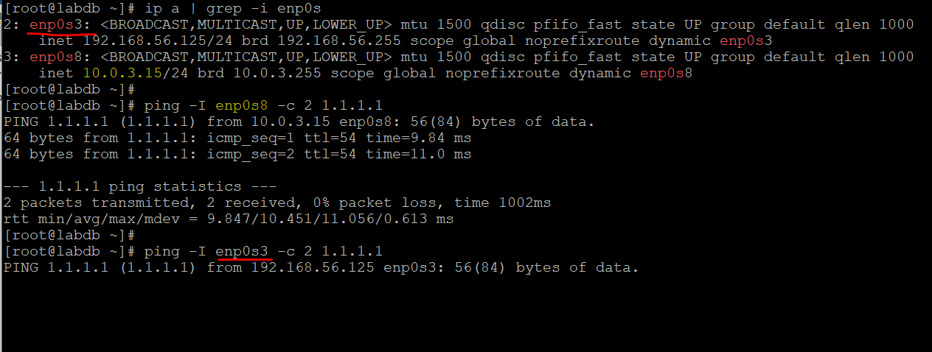

**LOCAL REPO CREATE & UPDATE**

**CentOS 7 ISO need to be mounted on CentOS7 Minimal and Oracle Virtual Box Setting.**

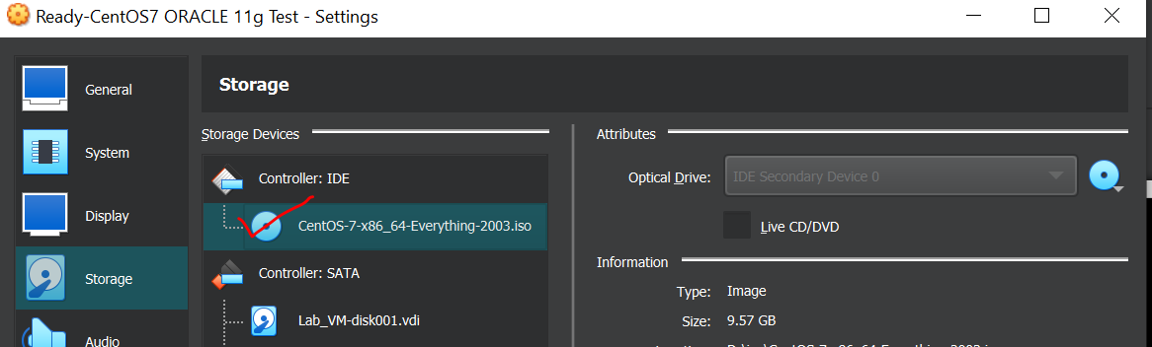



CentOS 7 [Everything][x86_64[1804][ISO]Download Link 9GB : <https://archive.org/details/CentOS7X8664Everything1804>

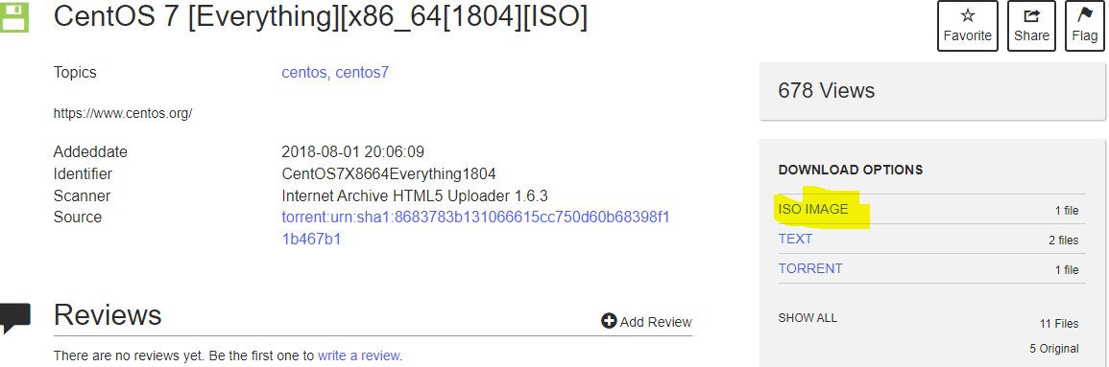

**Creating CentOS 7 Repo “ >> /etc/yum.repos.d/centos_dvd.repo ”**

#echo "[centos-7-dvd] " >> /etc/yum.repos.d/centos_dvd.repo

#echo "name = CentOS 7 DVD " >> /etc/yum.repos.d/centos_dvd.repo

#echo "baseurl = file:///mnt " >> /etc/yum.repos.d/centos_dvd.repo

#echo "enabled = 1 " >> /etc/yum.repos.d/centos_dvd.repo

#echo "gpgcheck = 0 " >> /etc/yum.repos.d/centos_dvd.repo

#yum update -y

INSTALLATION DEPENDENCIES FOR ORACLE DATABASE

#yum install binutils compat-libstdc++-33 compat-libstdc++-33.i686 gcc gcc-c++ glibc glibc.i686 glibc-devel glibc-devel.i686 ksh libgcc libgcc.i686 libstdc++ libstdc++.i686 libstdc++-devel libstdc++-devel.i686 libaio libaio.i686 libaio-devel libaio-devel.i686 libXext libXext.i686 libXtst libXtst.i686 libX11 libX11.i686 libXau libXau.i686 libxcb libxcb.i686 libXi libXi.i686 make sysstat unixODBC unixODBC-devel zlib-devel elfutils-libelf-devel -y

SELINUX SET TO ***PREMISSIVE*** MODE

#sed -i 's/ SELINUX= enforcing/ SELINUX=permissive/g' /etc/selinux/config

HOSTNAME

#hostnamectl set-hostname labdb.example.com

ADD HOSTS ENTRY UNDER “/etc/hosts”

#echo "127.0.0.1 labdb labdb.example.com localhost localhost.localdomain" >> /etc/hosts

#echo "192.168.56.125 labdb labdb.example.com" >> /etc/hosts

CREATE USER & GROUP FOR ORACLE

#/usr/sbin/groupadd -g 501 oinstall

#/usr/sbin/groupadd -g 502 dba

#/usr/sbin/groupadd -g 503 oper

#/usr/sbin/useradd -u 502 -g oinstall -G dba,oper oracle

#echo "oracle" |passwd --stdin oracle

SET KERNEL PARAMETER FOR ORACLE DATABASE INSTALLATION UNDER “/etc/sysctl.conf”

#echo "kernel.shmmni = 4096" >> /etc/sysctl.conf

#echo "kernel.shmmax = 4398046511104" >> /etc/sysctl.conf

#echo "kernel.shmall = 1073741824" >> /etc/sysctl.conf

#echo "kernel.sem = 250 32000 100 128" >> /etc/sysctl.conf

#echo "fs.aio-max-nr = 1048576" >> /etc/sysctl.conf

#echo "fs.file-max = 6815744" >> /etc/sysctl.conf

#echo "net.ipv4.ip_local_port_range = 9000 65500" >> /etc/sysctl.conf

#echo "net.core.rmem_default = 262144" >> /etc/sysctl.conf

#echo "net.core.rmem_max = 4194304" >> /etc/sysctl.conf

#echo "net.core.wmem_default = 262144" >> /etc/sysctl.conf

#echo "net.core.wmem_max = 1048586" >> /etc/sysctl.conf

#/sbin/sysctl -p

SET USER LIMITATION FOR ORACLE DATABASE INSTALLATION UNDER “/etc/security/limits.conf”

echo "oracle soft nproc 131072" >> /etc/security/limits.conf

echo "oracle hard nproc 131072" >> /etc/security/limits.conf

echo "oracle soft nofile 131072" >> /etc/security/limits.conf

echo "oracle hard nofile 131072" >> /etc/security/limits.conf

echo "oracle soft core unlimited" >> /etc/security/limits.conf

echo "oracle hard core unlimited" >> /etc/security/limits.conf

echo "oracle soft memlock 50000000" >> /etc/security/limits.conf

echo "oracle hard memlock 50000000" >> /etc/security/limits.conf

CREATE DIRECTORY STRUCTURE

#mkdir -p /ora01/app

#chown oracle:oinstall /ora01/app

#chmod -R 775 /ora01/app

CREATE ORACLE_BASE DIRECTORY FOR ORACLE DB

#mkdir -p /ora01/app/oracle

#chown oracle:oinstall /ora01/app/oracle

#chmod -R 775 /ora01/app/oracle

CREATE ORACLE_HOME DIRECTORY FOR ORACLE DB

#mkdir -p /ora01/app/oracle/product/11.2.0/db_1

#chown oracle:oinstall -R /ora01/app/oracle

AFTER CREATING “oracle” USER, IT NEED TO MODIFY “/home/oracle/.bash_profile”

*# Oracle Settings*

*export TMP=/tmp*

*export ORACLE_HOSTNAME=****labdb.example.com***

*export ORACLE_UNQNAME=****centlab11g***

*export ORACLE_BASE=/ora01/app/oracle*

*export ORACLE_HOME=$ORACLE_BASE/product/11.2.0/db_1*

*export ORACLE_SID=****centlab11g***

*PATH=/usr/sbin:$PATH:$ORACLE_HOME/bin*

*export LD_LIBRARY_PATH=$ORACLE_HOME/lib:/lib:/usr/lib;*

*export CLASSPATH=$ORACLE_HOME/jlib:$ORACLE_HOME/rdbms/jlib;*

*alias cdob='cd $ORACLE_BASE'*

*alias cdoh='cd $ORACLE_HOME'*

*alias tns='cd $ORACLE_HOME/network/admin'*

*alias envo='env | grep ORACLE'*

*umask 022*

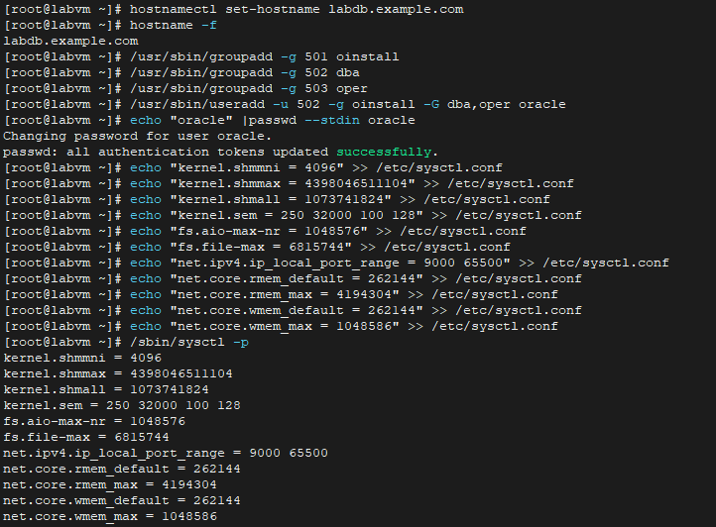

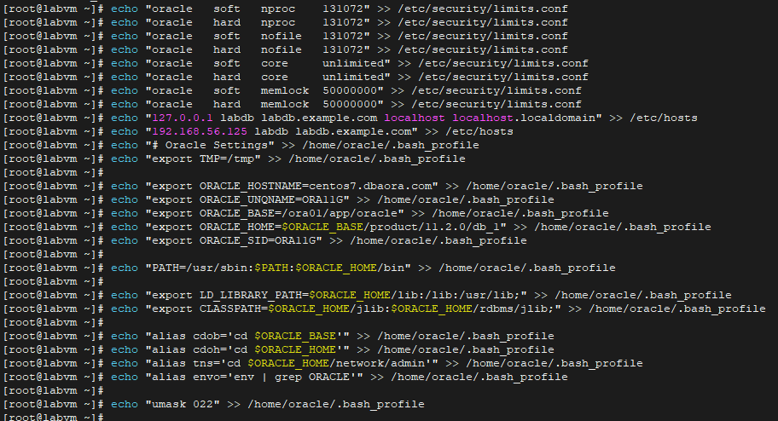

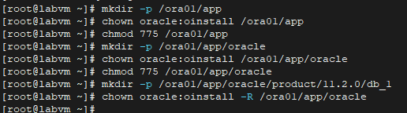

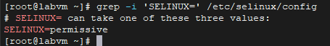

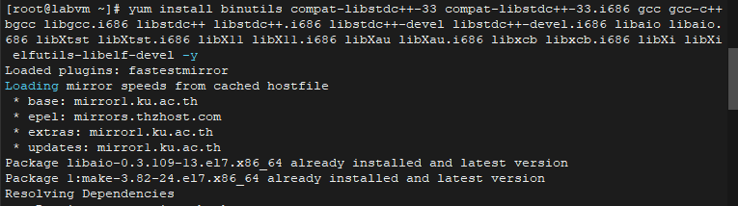

**Perquisites are done !**

XXXXX=XXXXX=XXXXX= XXXXX=XXXXX=XXXXX= XXXXX=XXXXX=XXXXX= XXXXX=XXXXX=XXXXX

**ORACLE 11G INSTALLATION**

p13390677_112040_Linux-x86-64_1of7.zip

p13390677_112040_Linux-x86-64_2of7.zip

DOWNLOAD> <https://drive.google.com/drive/folders/1ip7Jnl0CX8C1bcMVV15UxLr04jpdUZTj>

SWITCH USER TO “oracle” and unzip one by one

#su – oracle

#unzip p13390677_112040_Linux-x86-64_1of7.zip

#unzip p13390677_112040_Linux-x86-64_2of7.zip

AFTER FINISHING UNZIP FOR BOTH FILES, WE CAN SEE “***database***” folder.

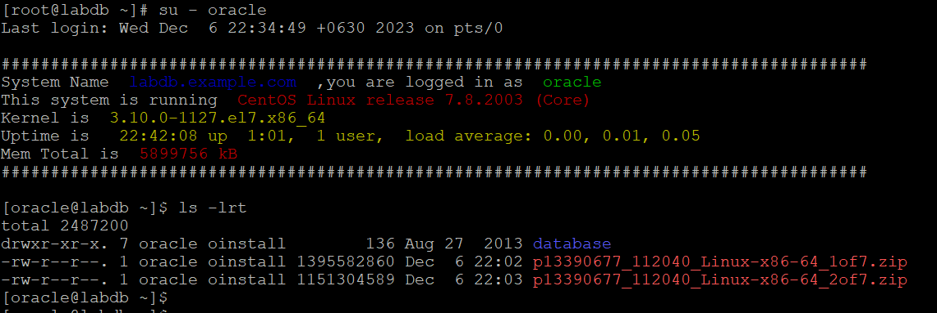

Then Start Installation Oracle 11g by running “ ./database/runInstaller ” but FAILED.

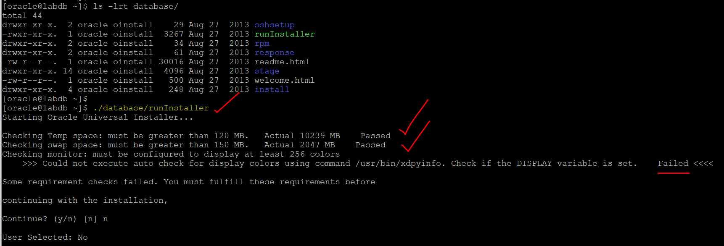

TO FIX

TO USE X11Forwarding FOR ORACLE INSTALLTION UI

#yum install xorg-x11* -y

Mobaxterm Download

<https://mobaxterm.mobatek.net/download-home-edition.html>

CHECK “/etc/ssh/sshd_config”

X11Forwarding yes

X11DisplayOffset 10

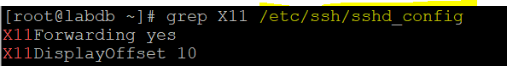

WE CAN USE: **PUTTY** or **Mobaxterm**

1. Using **PUTTY**

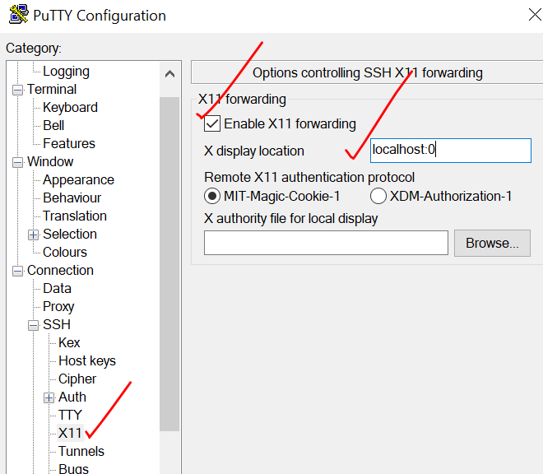

Login Again:

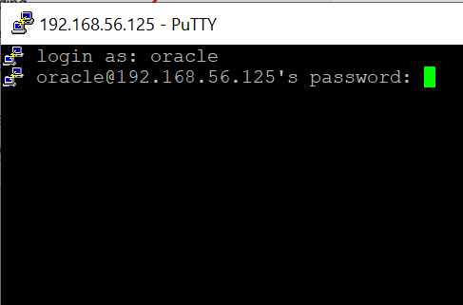

Just Opening **Mobaxterm** 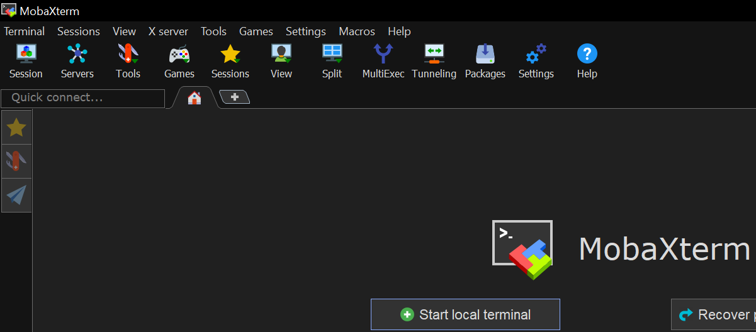

RUN in PUTTY

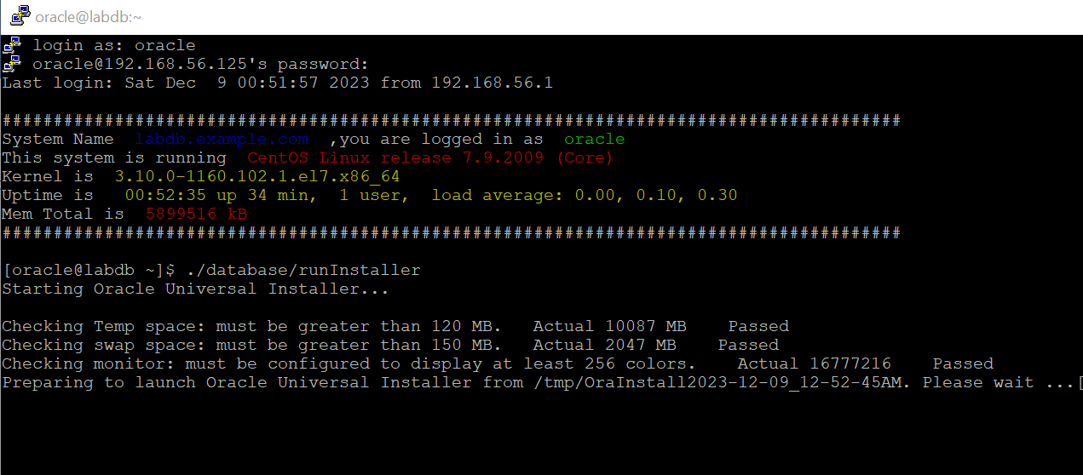

UI is coming up

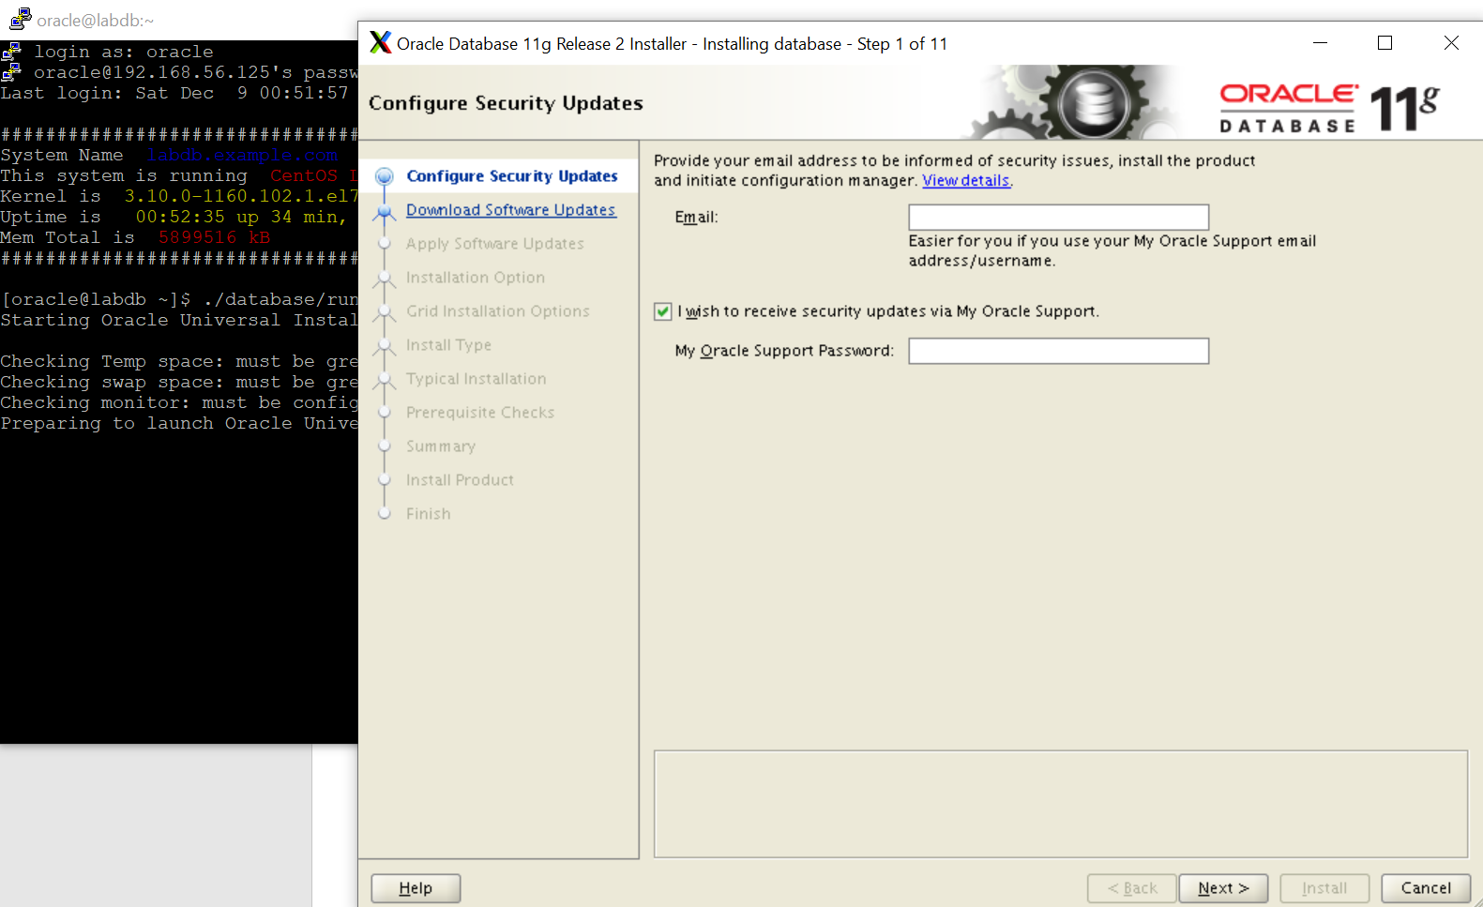

1. Using **Mobaxterm**

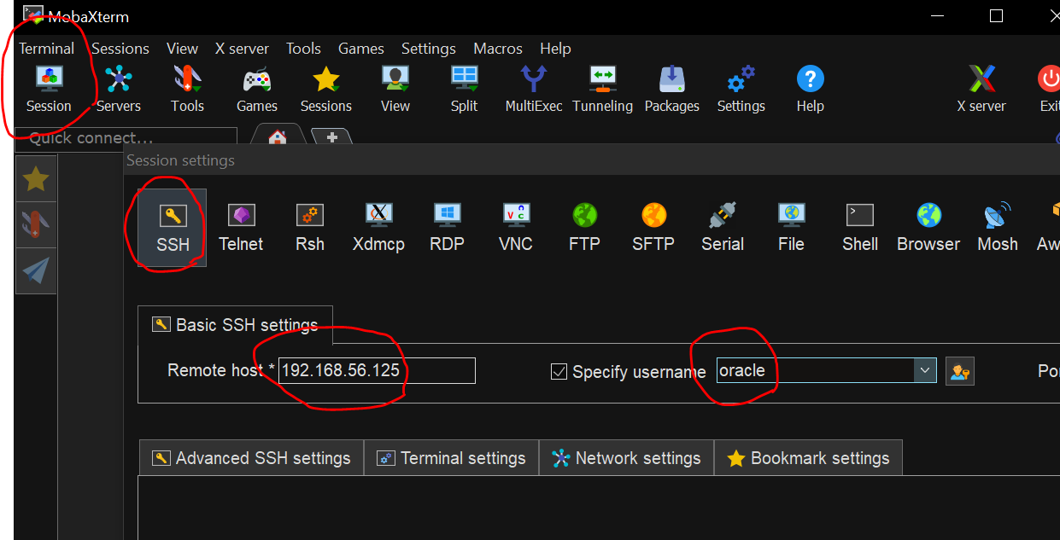

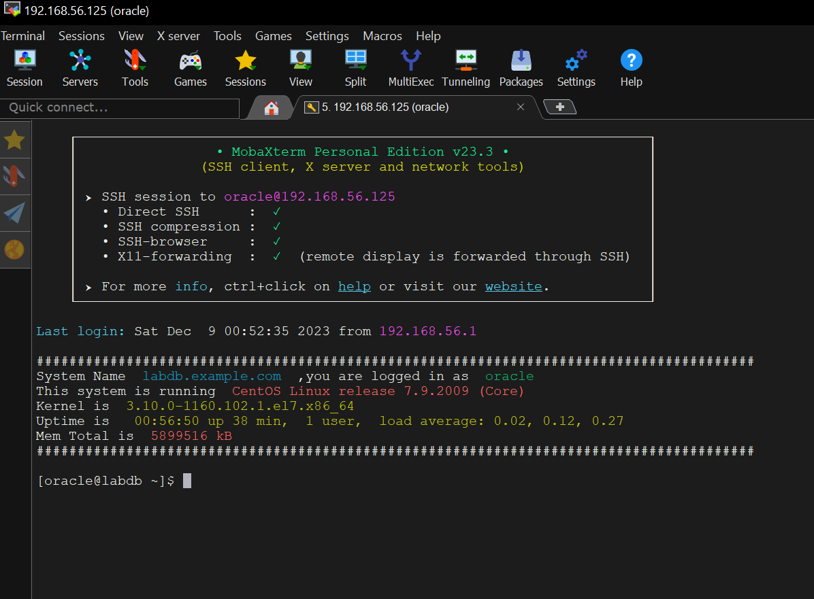

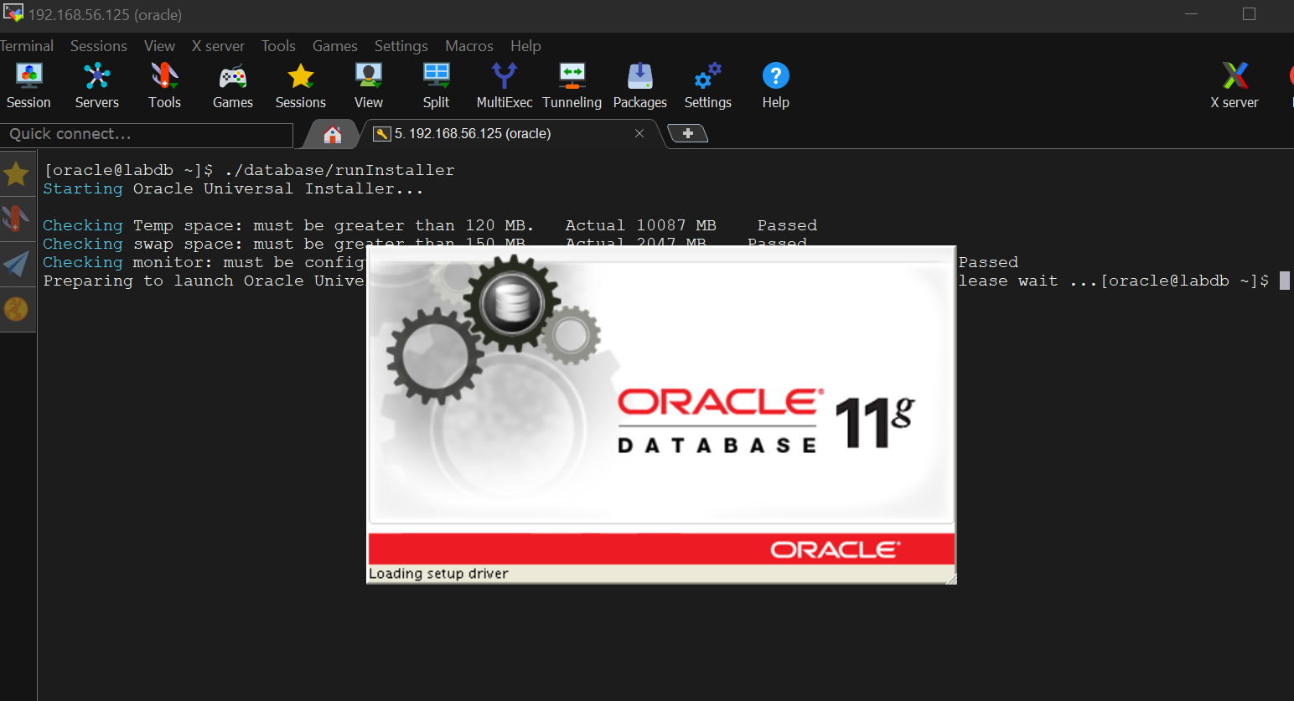

xxxxxxxxxxxxxxxxxxxxxxxxxxxxxxxxxxxxxxxxxxxxxxxxxxxxxxxxxxxxxxxxxxxxxxxxxxxxxxxxxxx

Let’s continue;

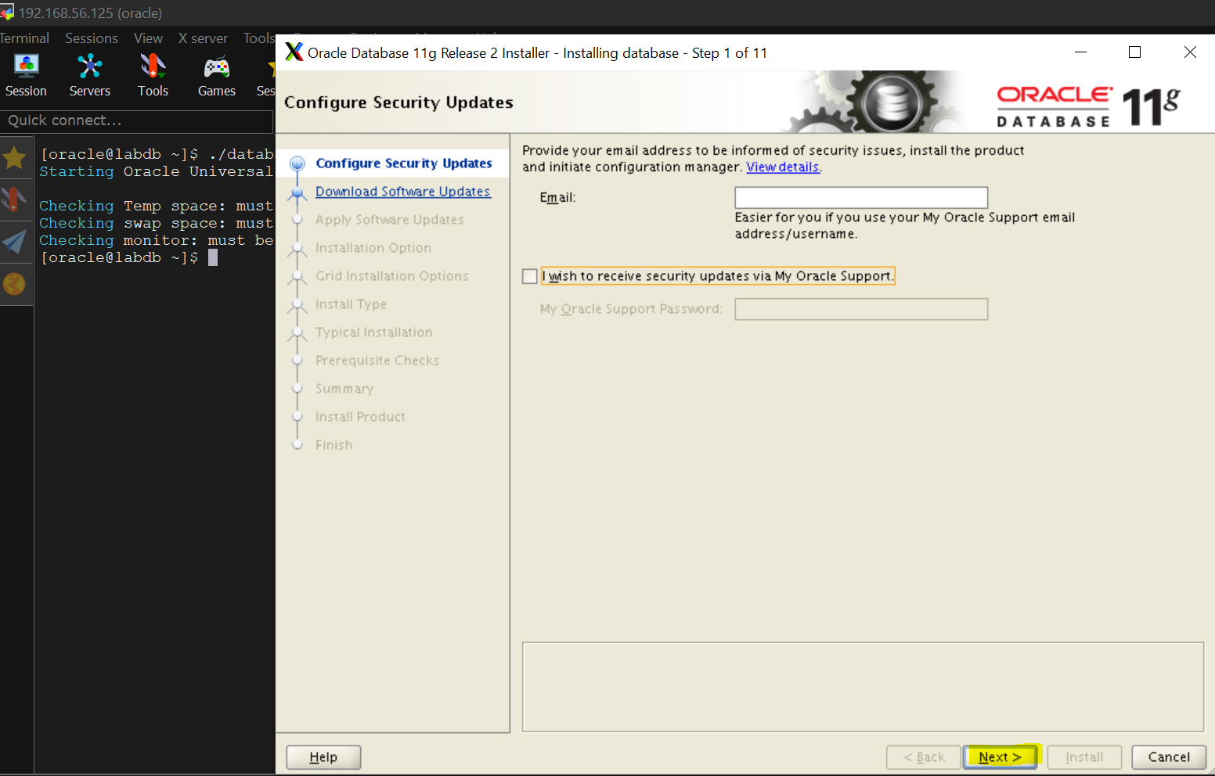 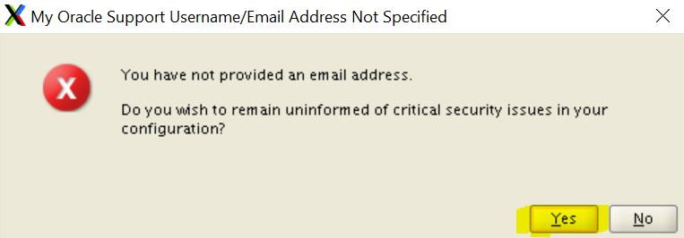 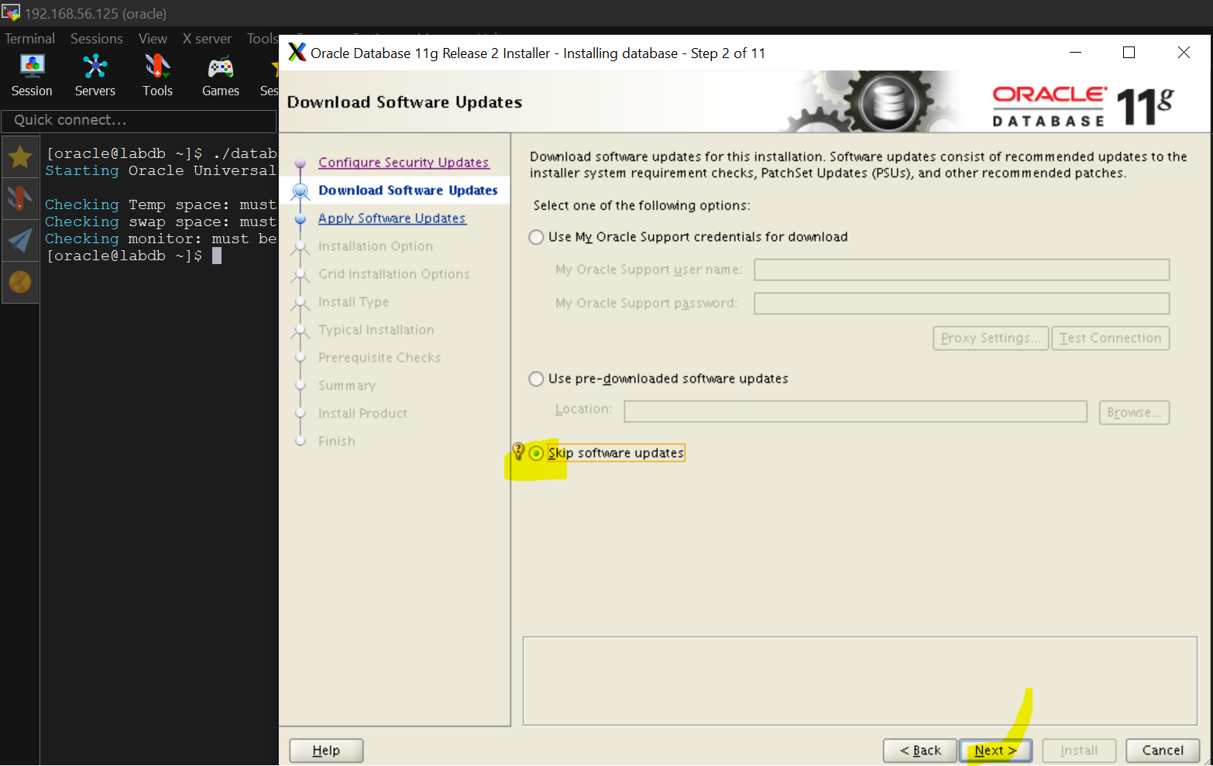 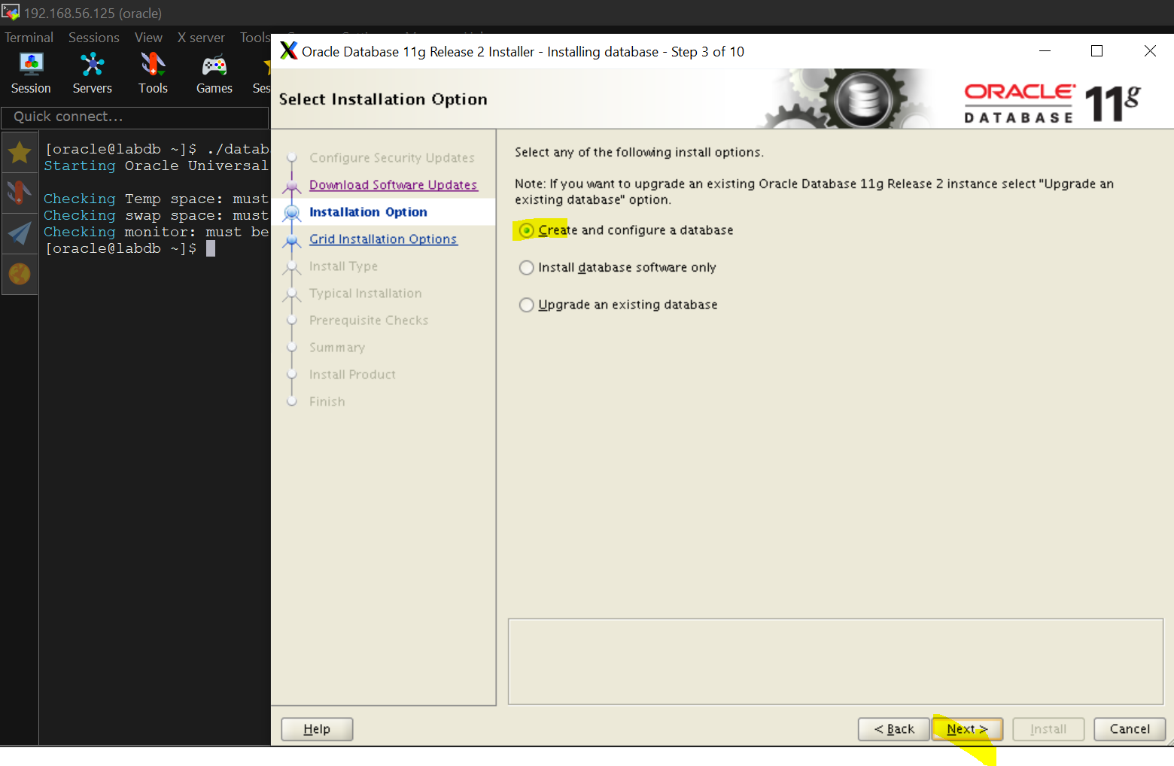 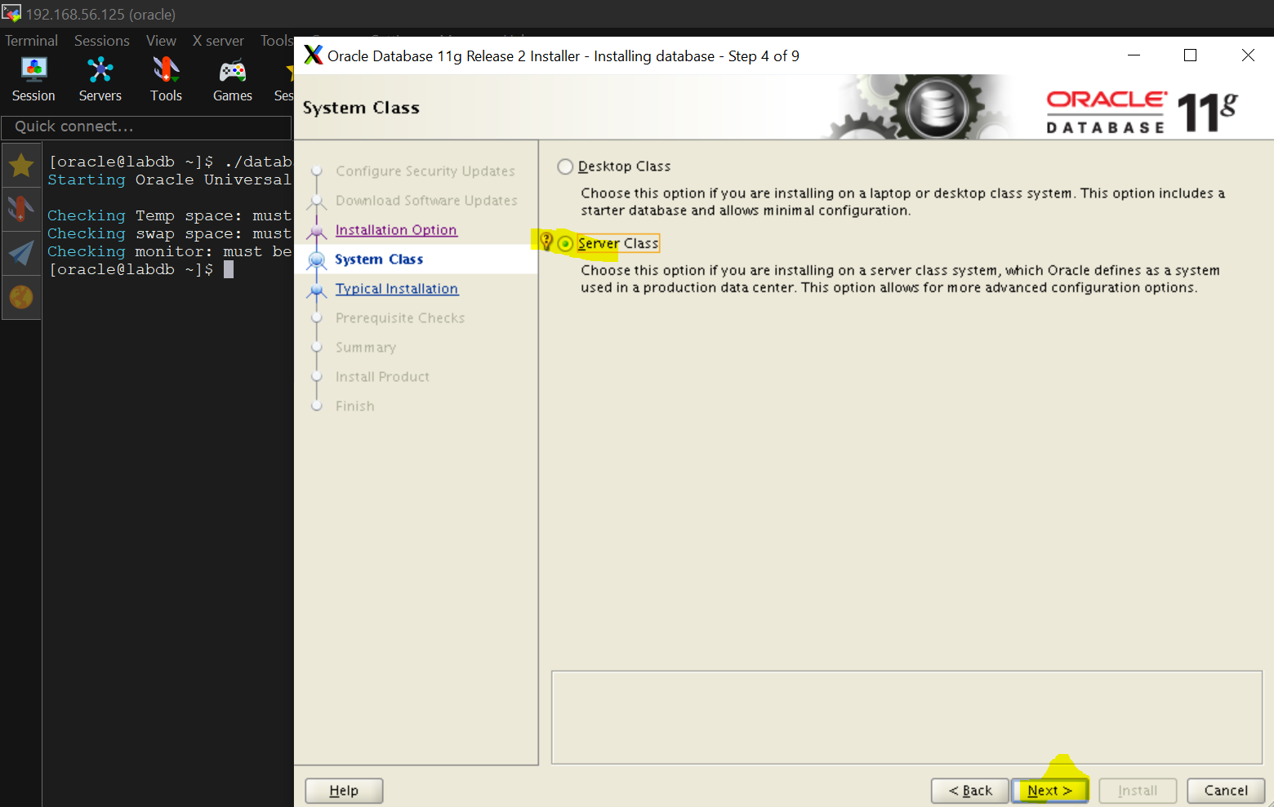

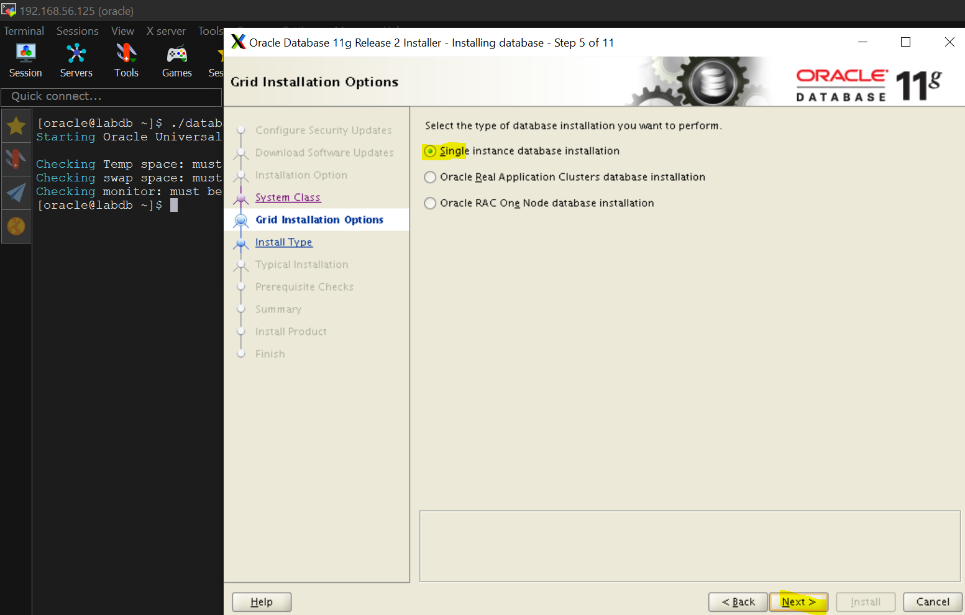 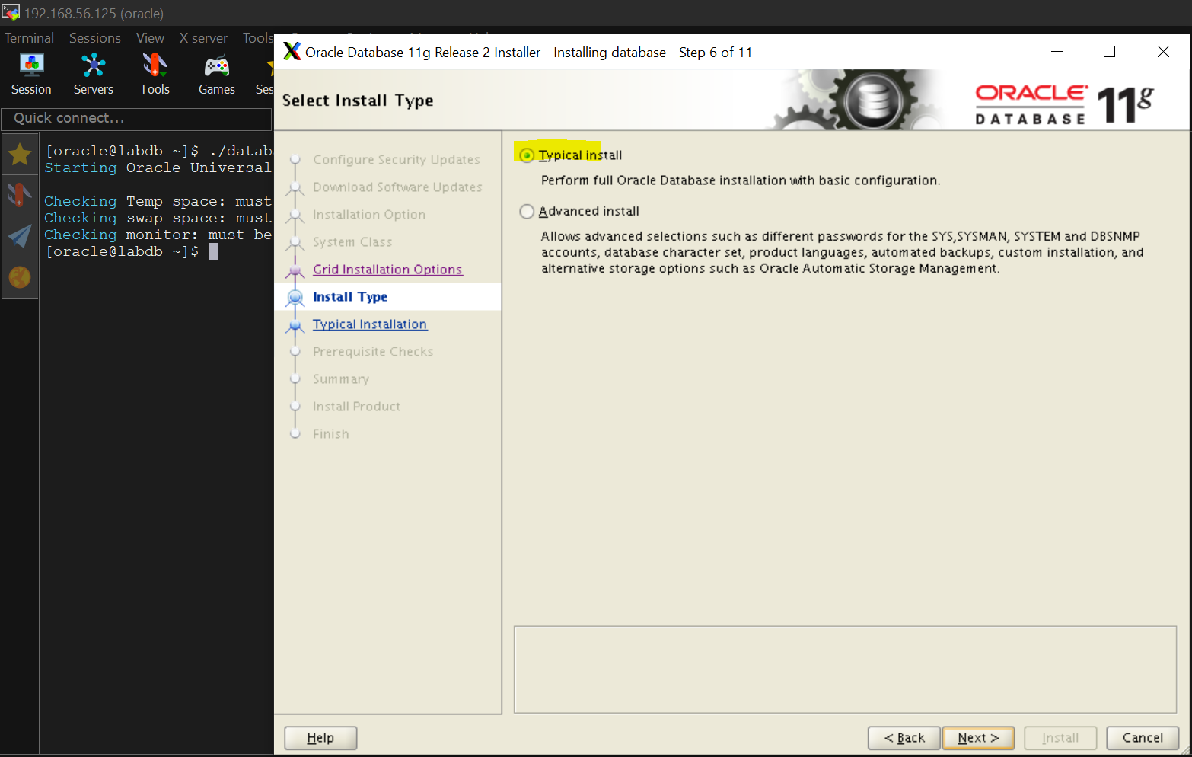

CHECK> **“ORACLE_UNQNAME”** in /home/oracle/.bash_profile

#cat /home/oracle/.bash_profile

OR

#grep -i **ORACLE_UNQNAME** /home/oracle/.bash_profile

OR

#echo $**ORACLE_UNQNAME**

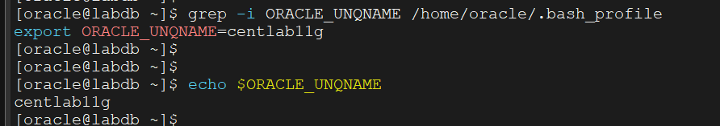

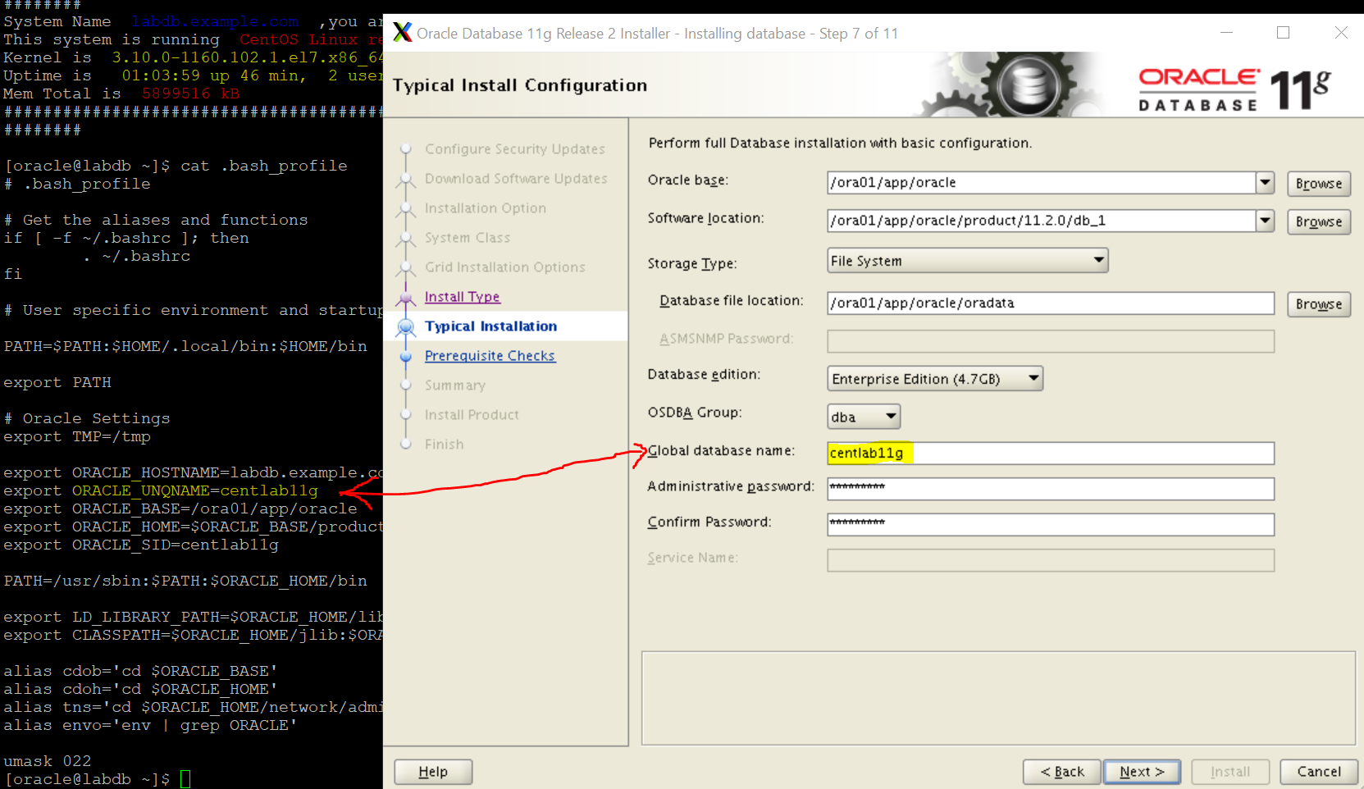 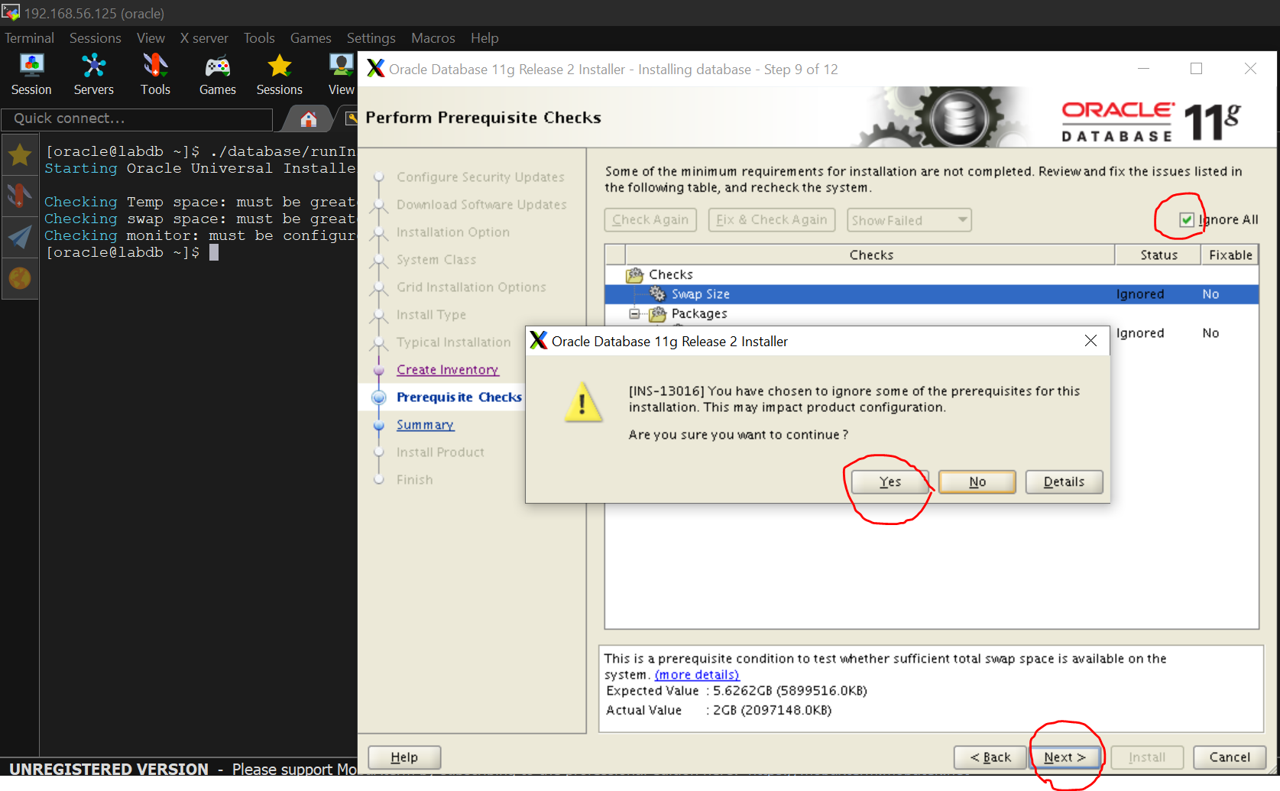 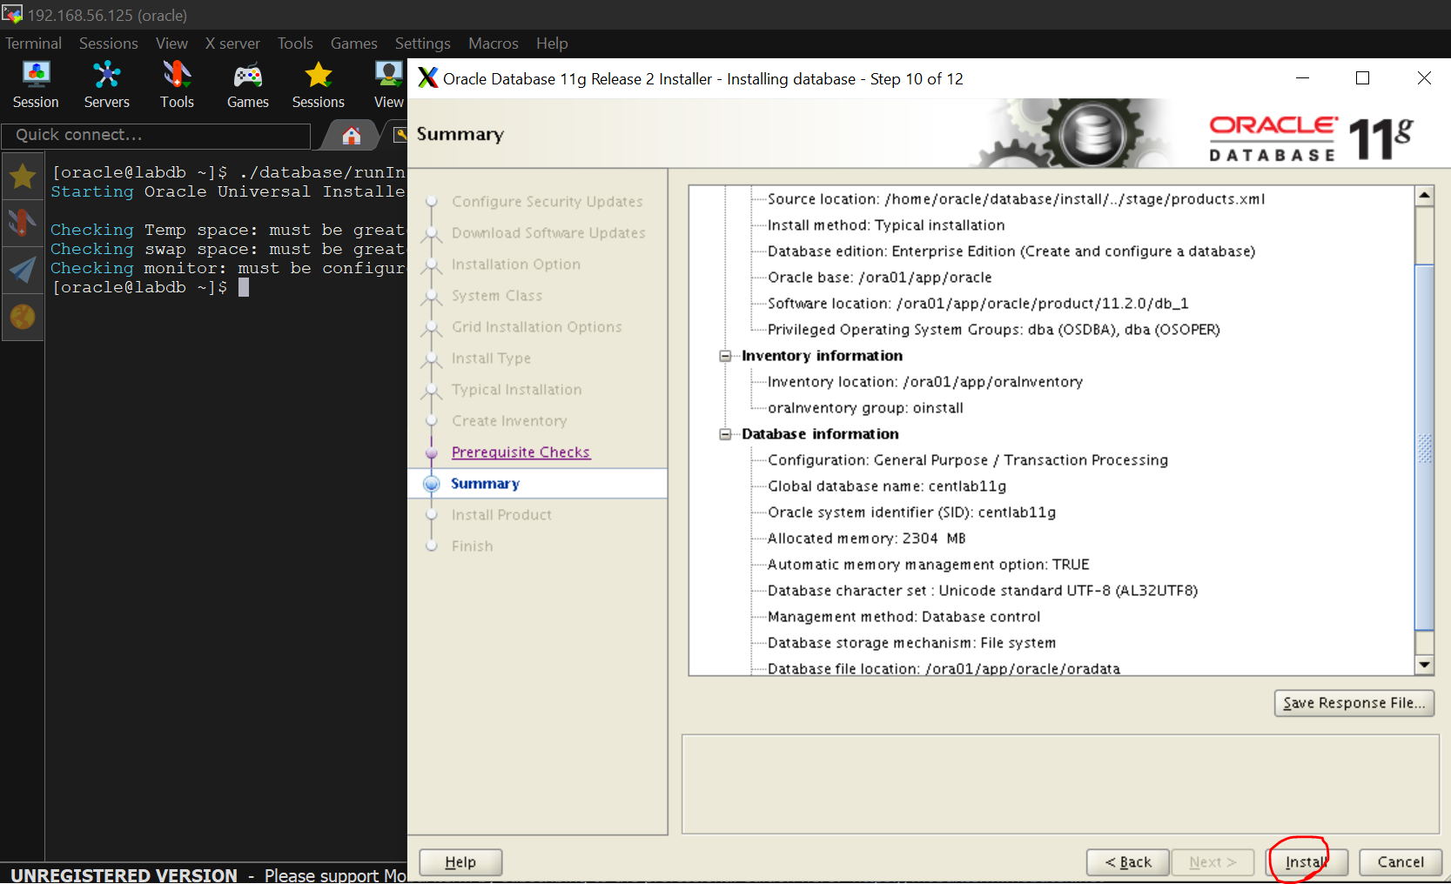 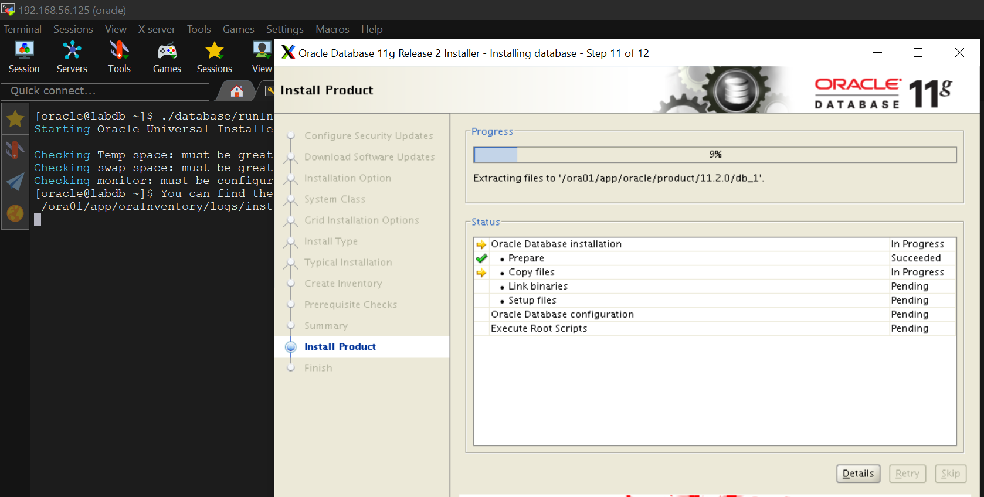

To fix this error edit $ORACLE_HOME/sysman/lib/ins_emagent.mk, search for the line

$(MK_EMAGENT_NMECTL)

and replace the line with

$(MK_EMAGENT_NMECTL) -lnnz11

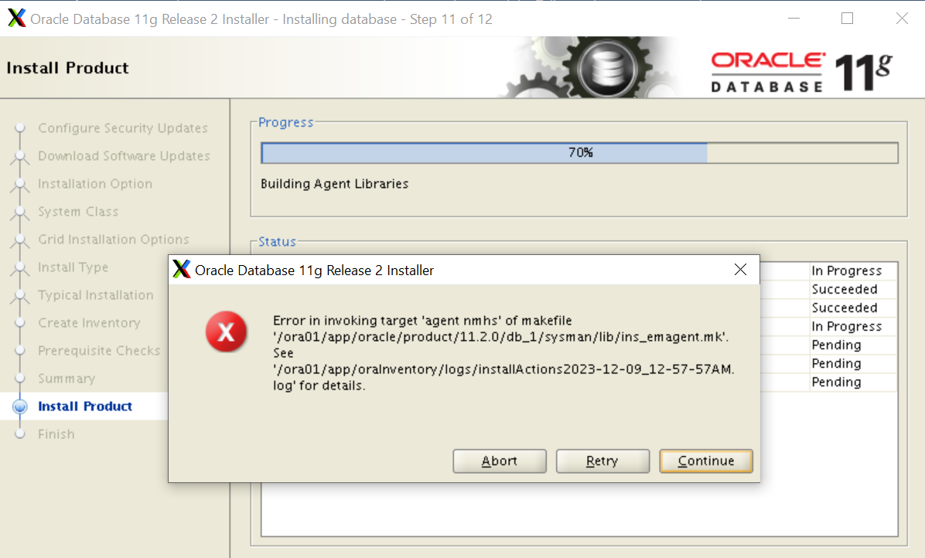

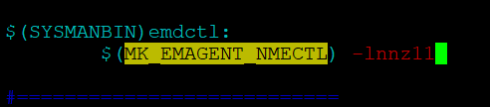 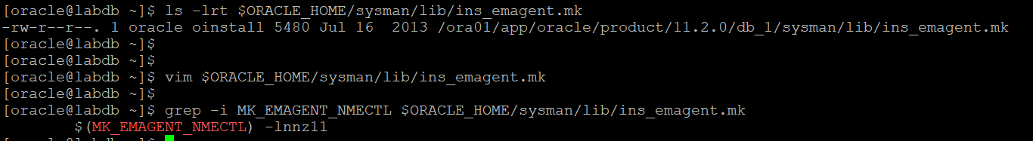

then click “Retry” button

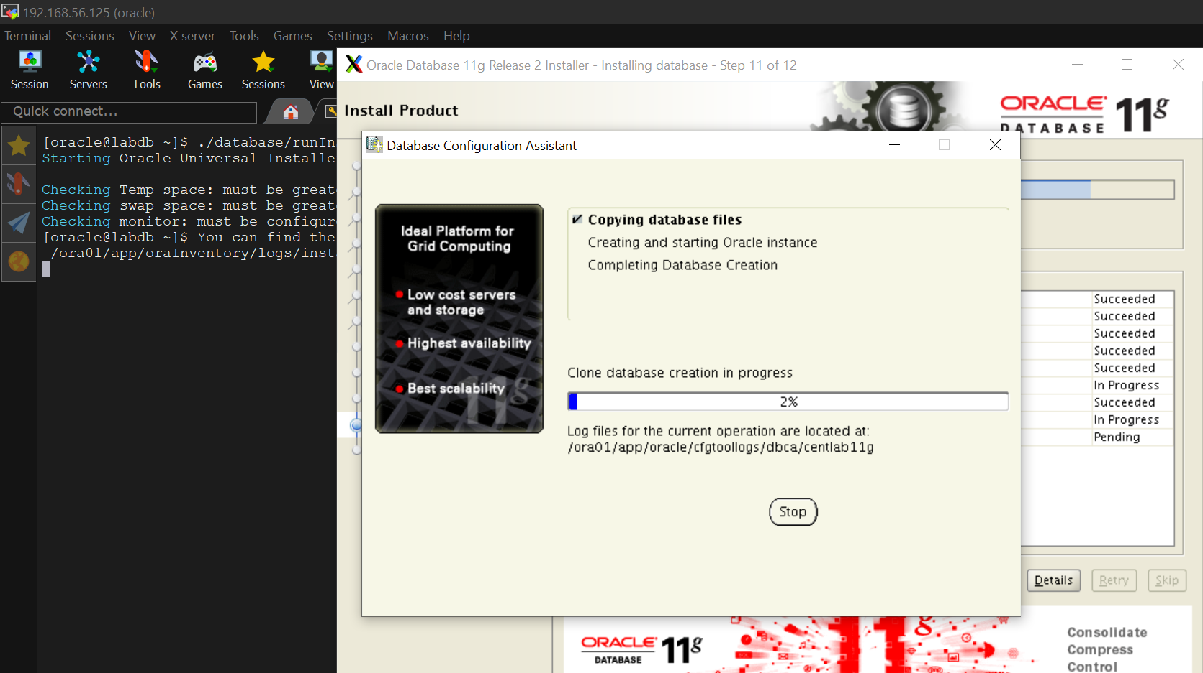

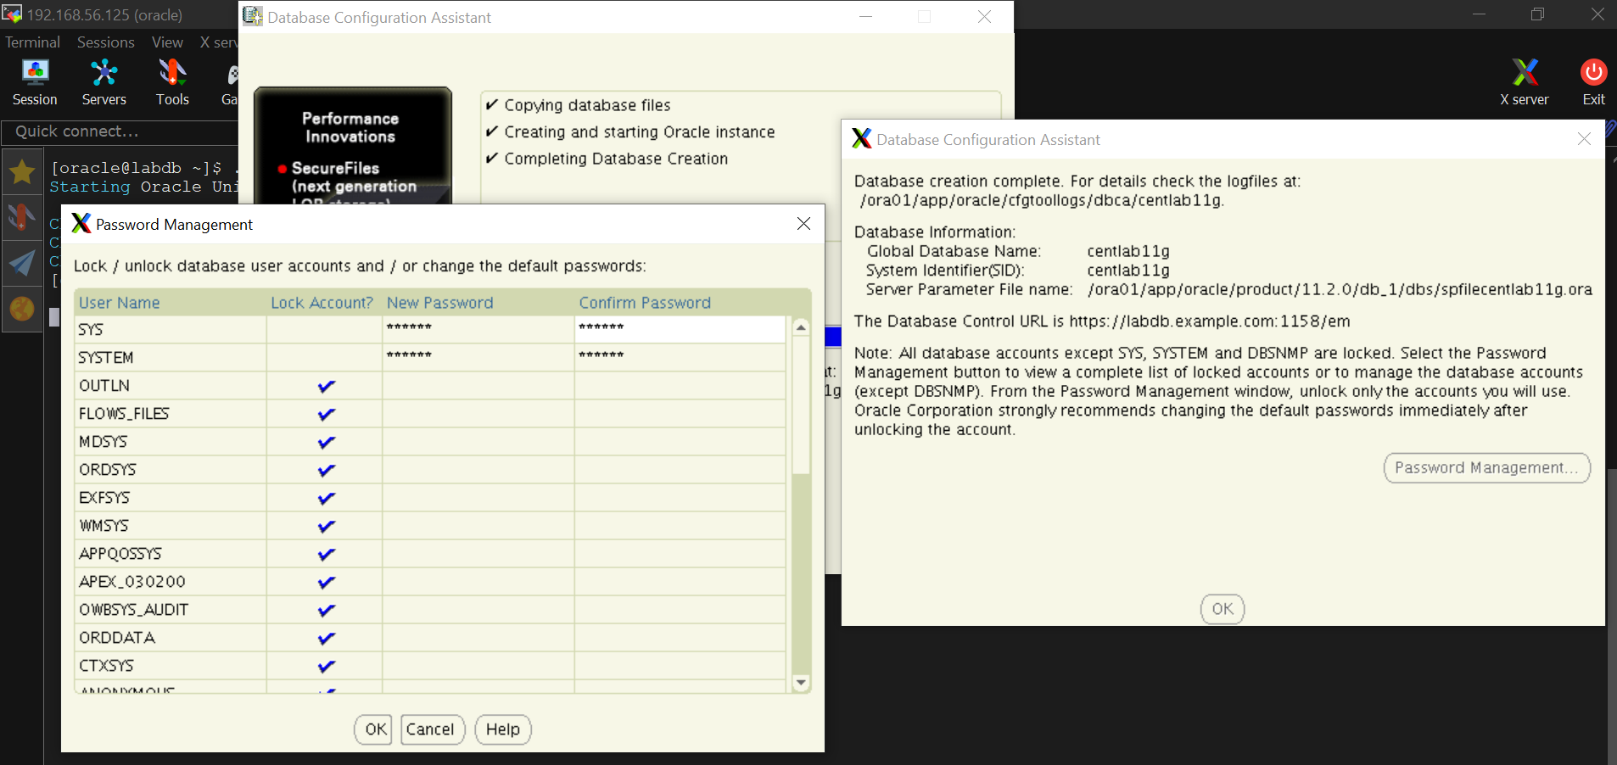

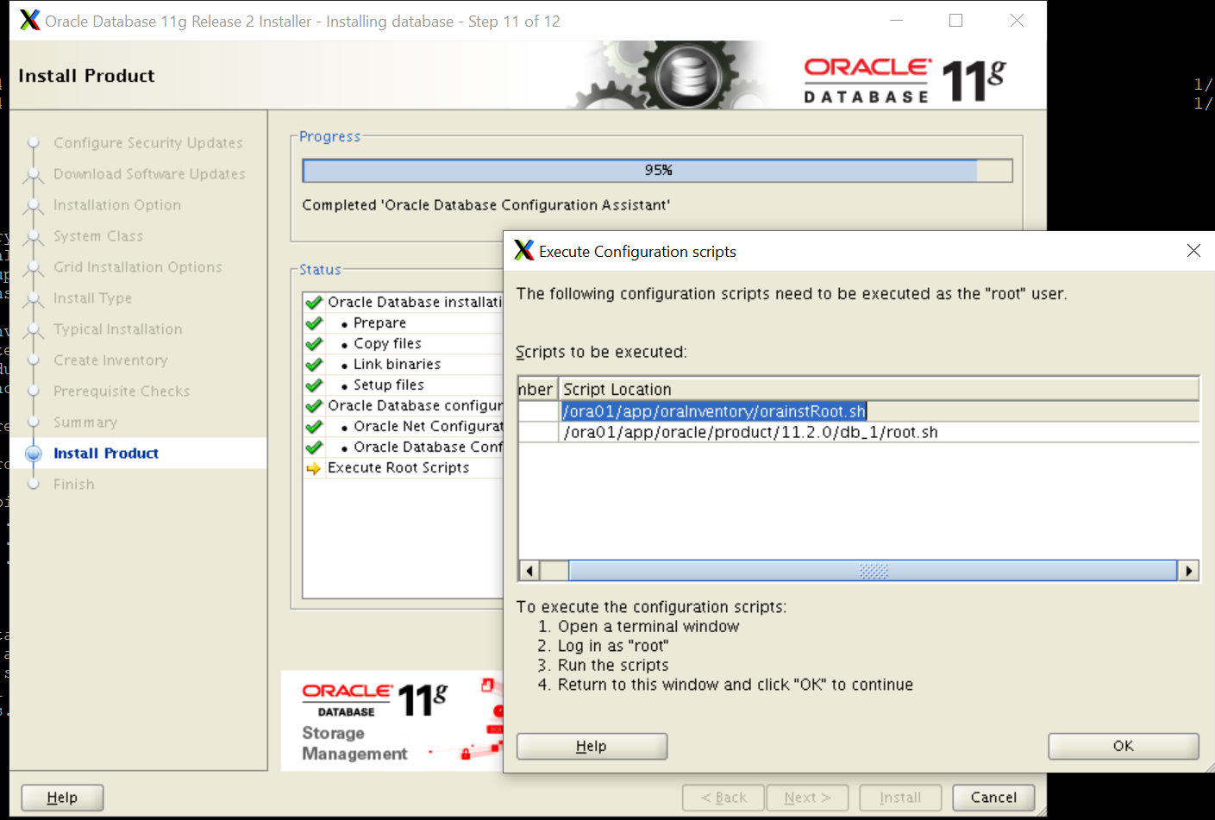

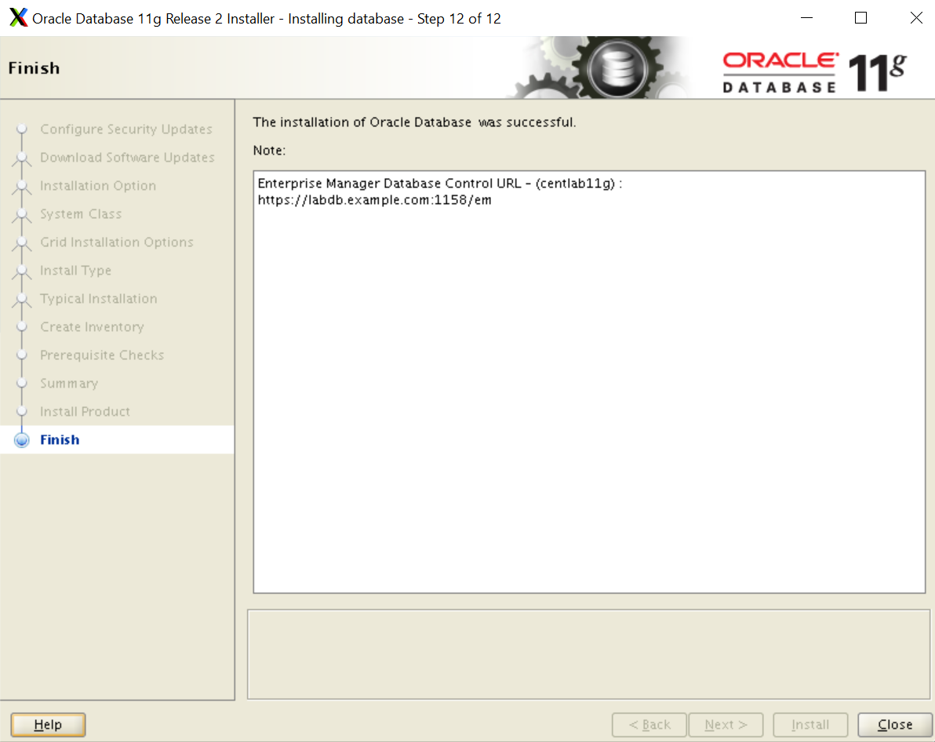

**Connect To the Oracle Database**

#sqlplus sys as sysdba

**Password>> oracle**

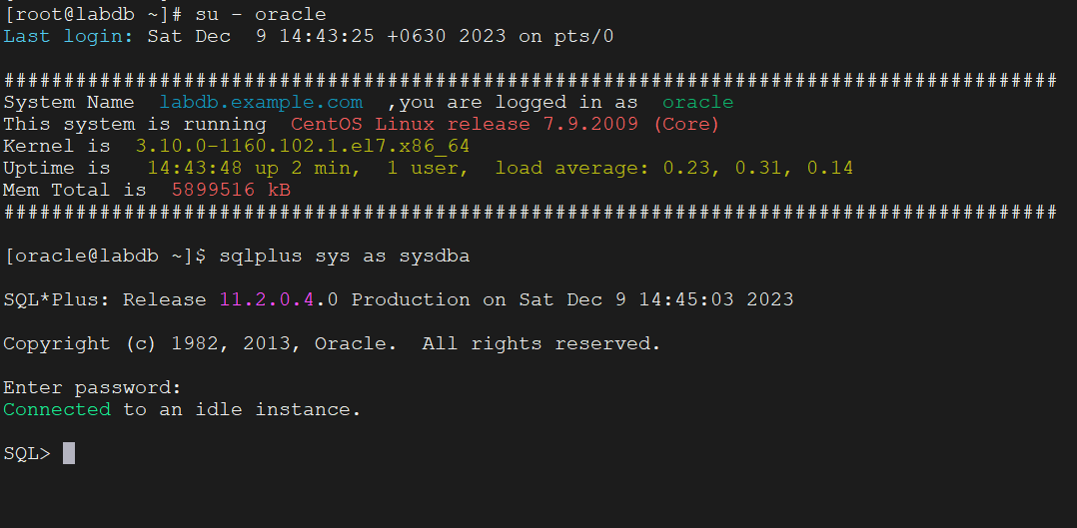

Start DB

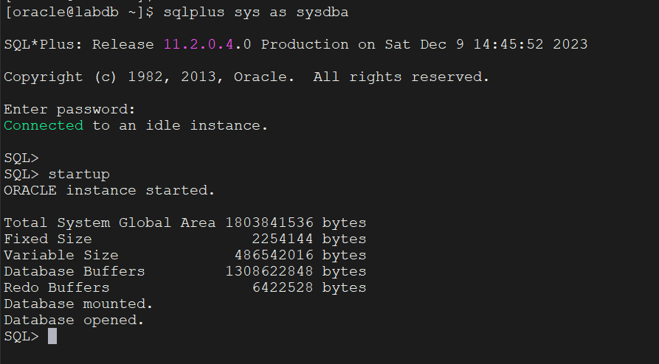

Try to Connect via SQL Developer Tool

<https://www.oracle.com/database/sqldeveloper/>

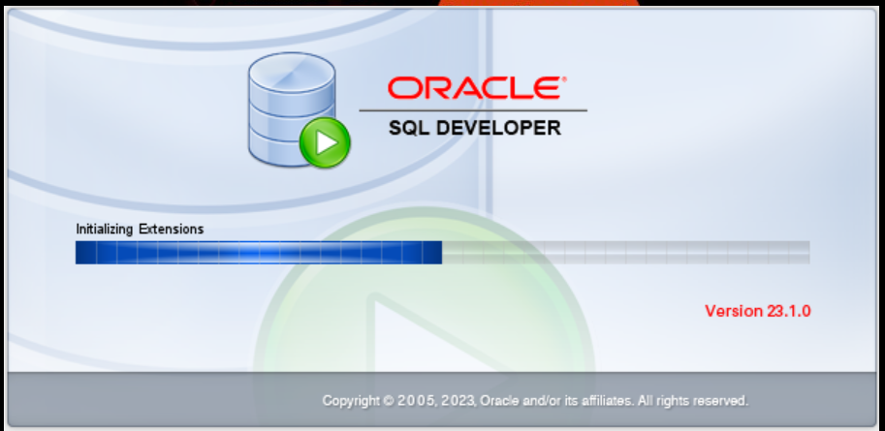

Network Connection Error

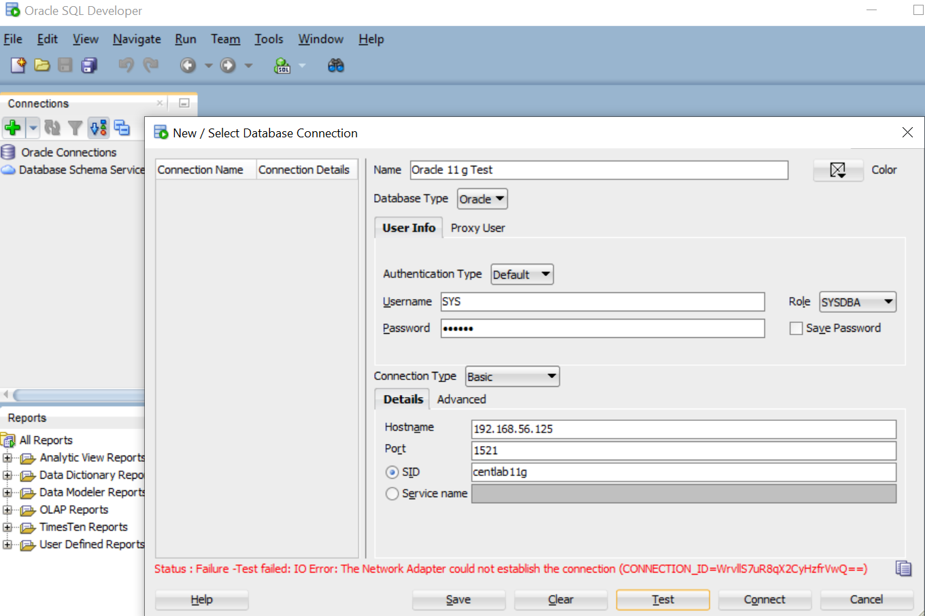

SID: cat /home/oracle/.bash_profile | grep SID

Port: 1521

Check the listener

#lsnrctl status

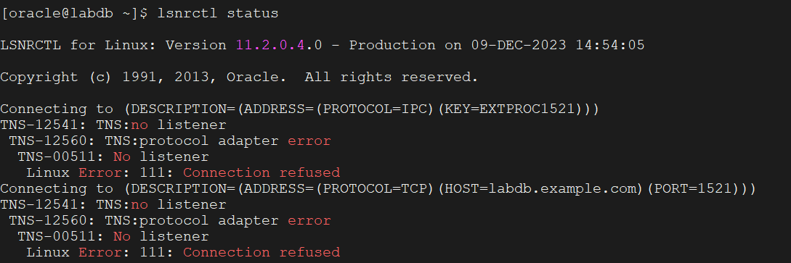

Start the listener

#lsnrctl stop/start

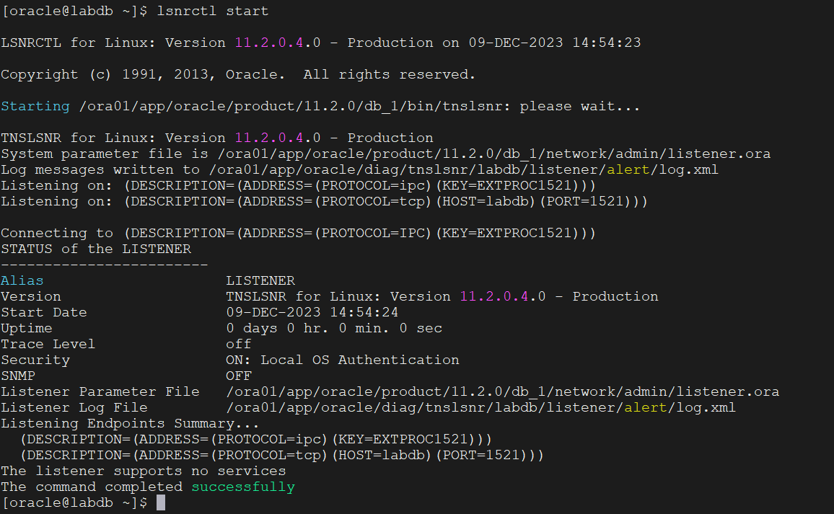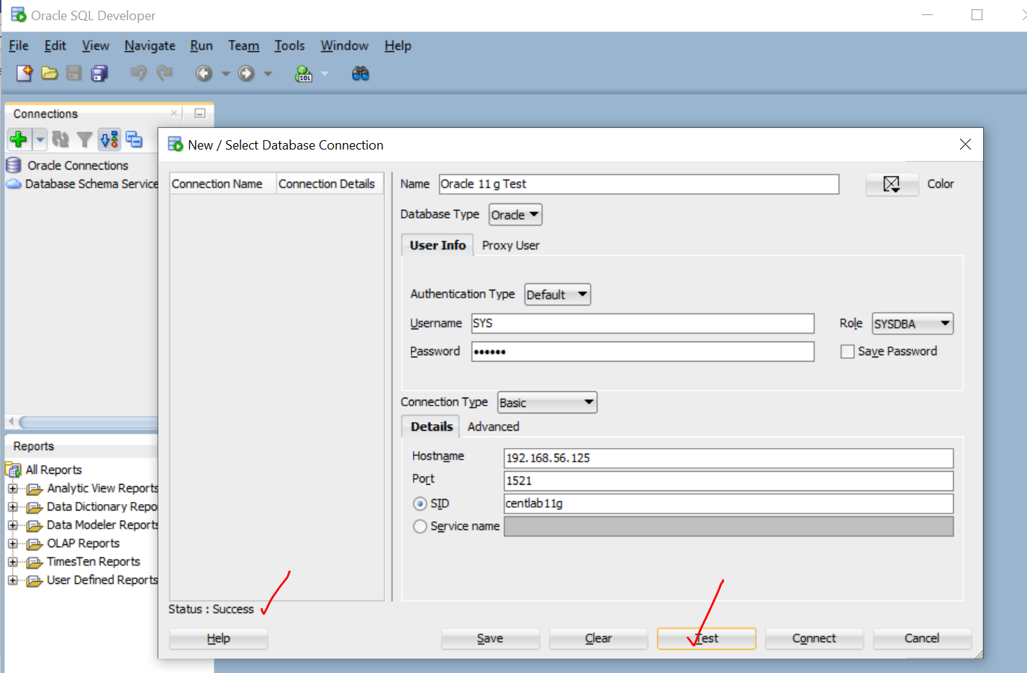

Query test:

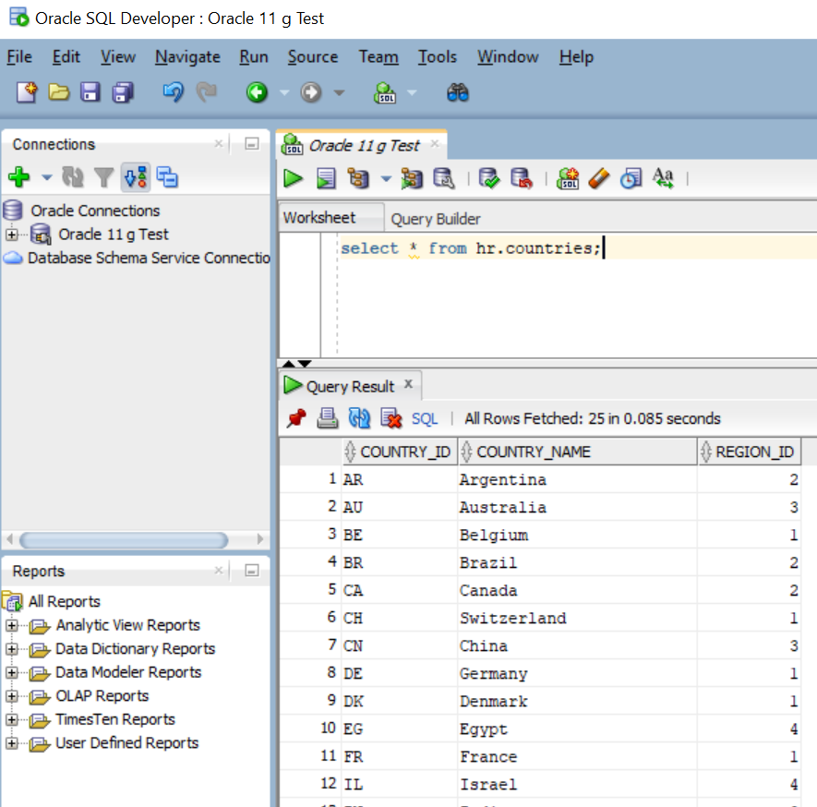

**ORACLE 11 g Installation on CentOS 7 is completed.**

**xxxxxxxxx xxxxxxxxx xxxxxxxxx xxxxxxxxx xxxxxxxxx xxxxxxxxx xxxxxxxxx xxxxxxxxx**

**ACCESSING FROM ORACLE ENTERPRISE MANAGER FROM Browser**

<https://simpleoracle.com/2015/10/11/oracle-database-11g-r2-issues-with-accessing-enterprise-manager-ssl_error_weak_server_cert_key/>

emctl status dbconsole

emctl start dbconsole

emctl unsecure dbconsole

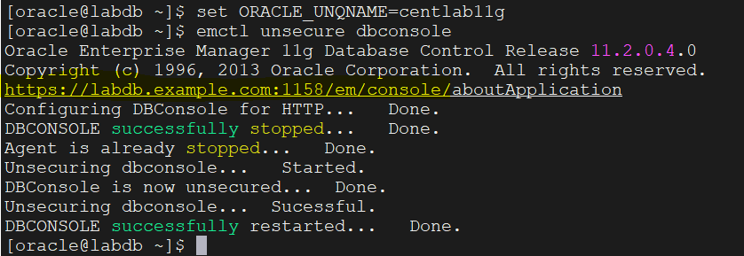

[**https://labdb.example.com:1158/em/**](https://labdb.example.com:1158/em/)

**USER= sys**

**Password= oracle**

**ContactAs= SYSDBA**

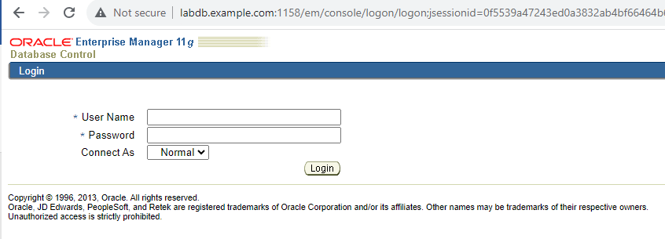

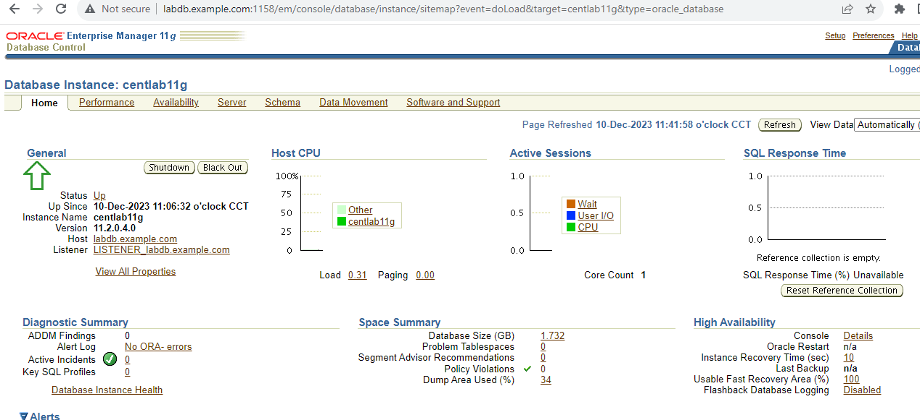

**xxxxxxxxx xxxxxxxxx xxxxxxxxx xxxxxxxxx xxxxxxxxx xxxxxxxxx xxxxxxxxx xxxxxxxxxxxxxxxxxxxxxx**